

S

u

b

j

e

c

t

N

a

m

e

:

**S**

**o**

**u**

**r**

**c**

**e**

**C**

**o**

**d**

**e**

**M**

**a**

**n**

**a**

**g**

**e**

**m**

**e**

**n**

**t**

S

u

b

j

e

c

t

C

o

d

e

:

**C**

**S**

**1**

**8**

**1**

C

l

u

s

t

e

r

:

B

E

T

A

D

e

p

a

r

t

m

e

n

t

:

**D**

**C**

**S**

**E**

**Submitted By:**

Aaryan Prabhakar

2110990018

G01

**Team Members:**

Abhimanyu Kashyap – 211099042

Abhinav Rawat – 2110990055

**Submitted To:**

Mr.Monit Kapoor

# 

# INDEX

|  |  |
| --- | --- |
| S. No. | Task Title |
| 1. | Add collaborators on GitHub Repository |
| 2. | Fork and Commit |
| 3. | Merge and Resolve conflicts |
| 4. | Reset and revert |



## Add collaborators on GitHub Repository

1. Create a New Repository.

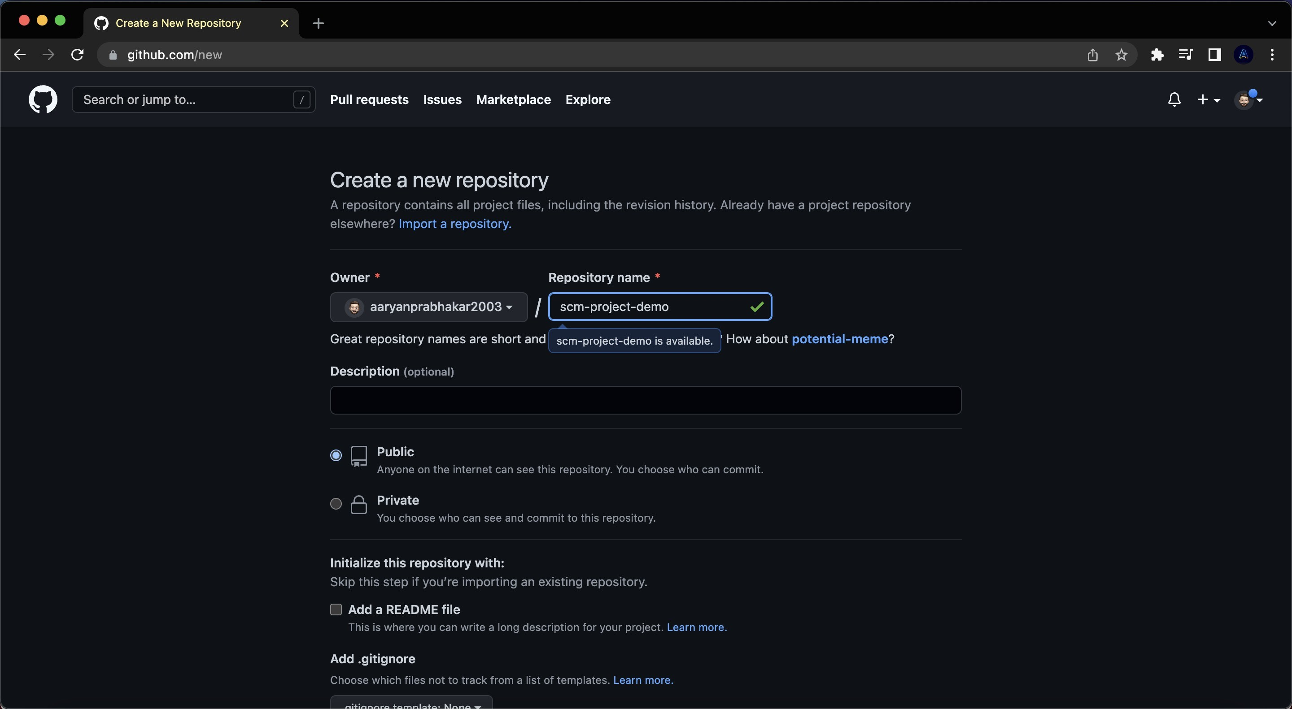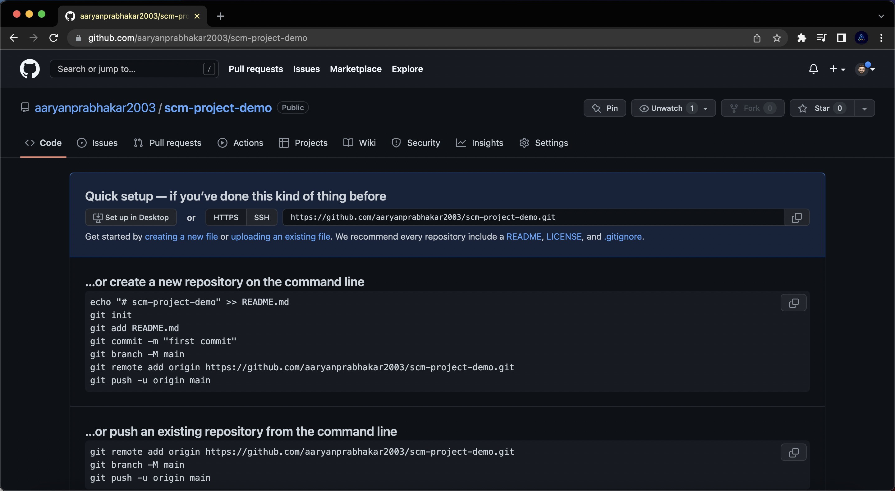

2. Now Copy the HTTP link of your repository and paste it in the terminal, and merge the local repository in remote repository.

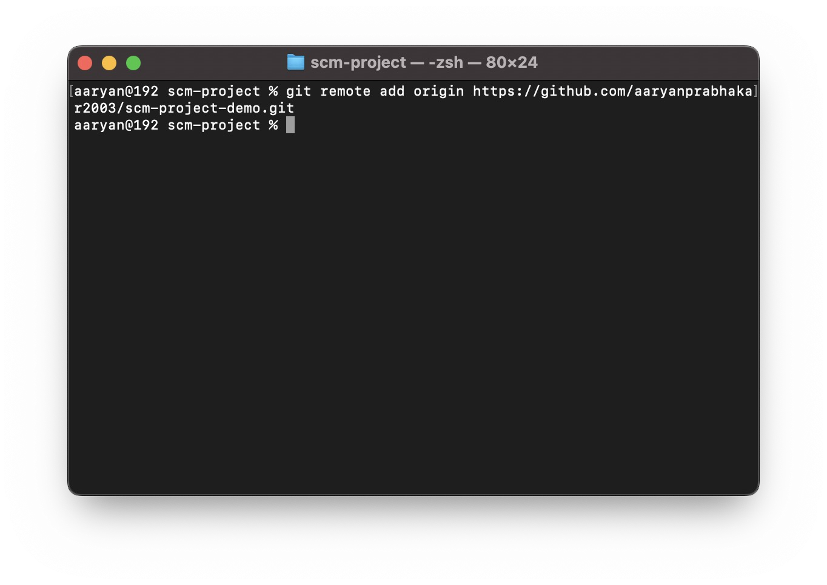

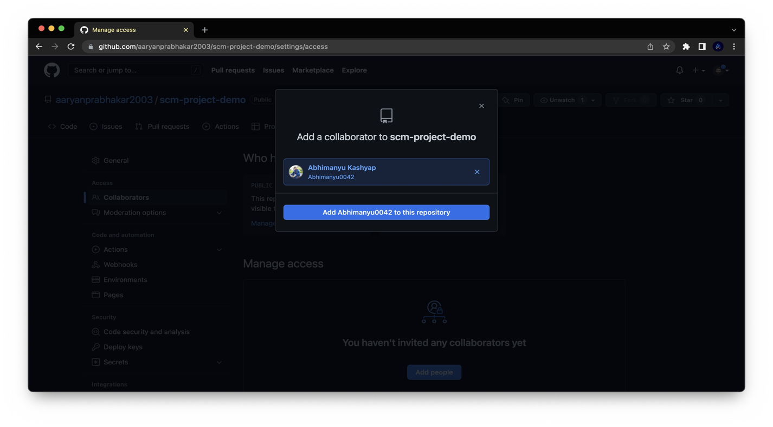3) " Go to Collaborators in Repository Setting , add the username or email of Collaborator you want to add in your Repository.

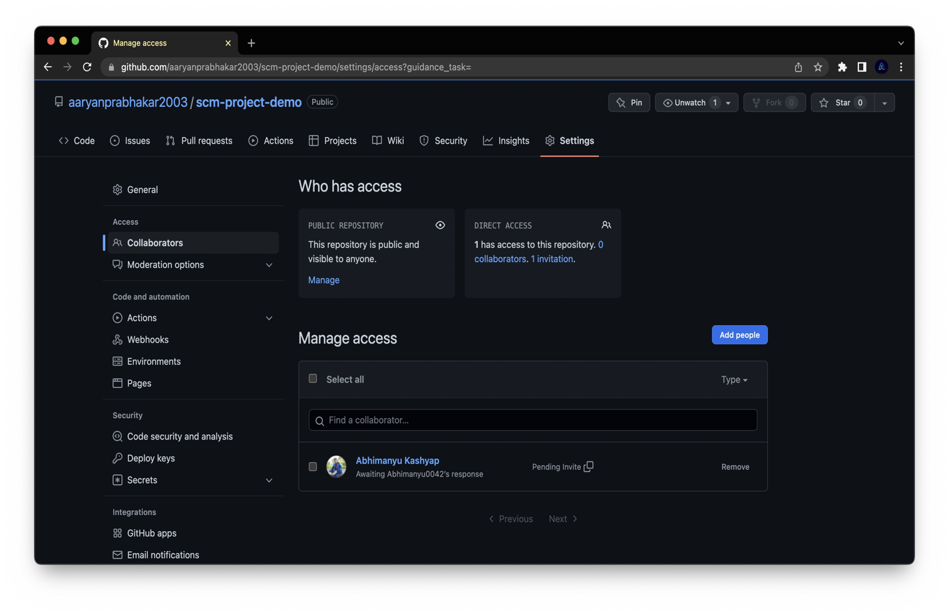

1. Invitation Mail is sent to the Collaborator. After the collaborator has to accept the his Invitation.

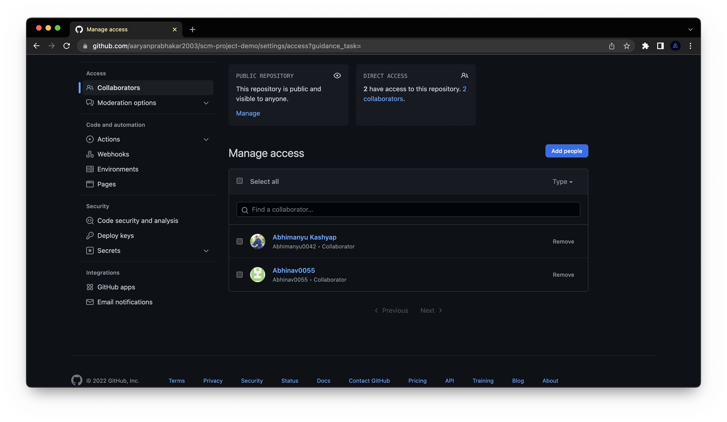

1. New Collaborator can now access the repository.



## Fork and Commit

1. Create a New Repository (or Folder) and Initialized the Git repository, Using ‘git init’ command. And add origin of your remote Repository to local Repository.

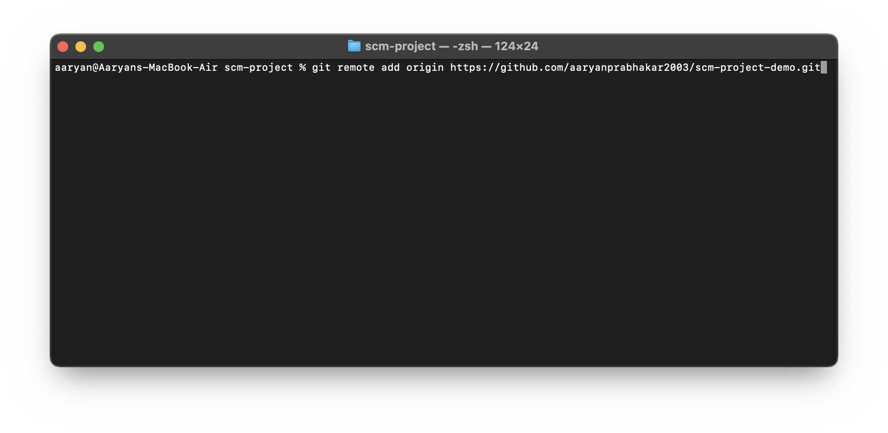

Git pull <URL> ◊This command is used to fetch the remote repository or to clone the repository.

2. Type “Git pull <link of repository>” on CLI.

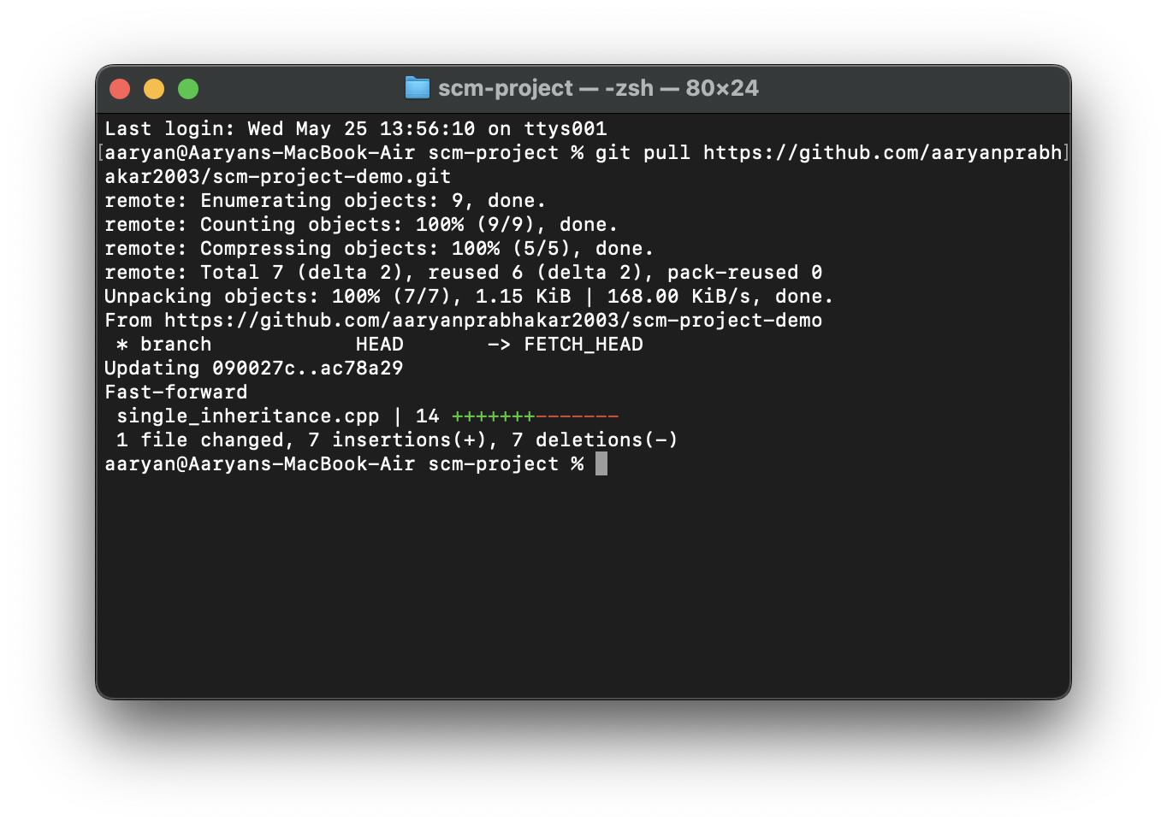

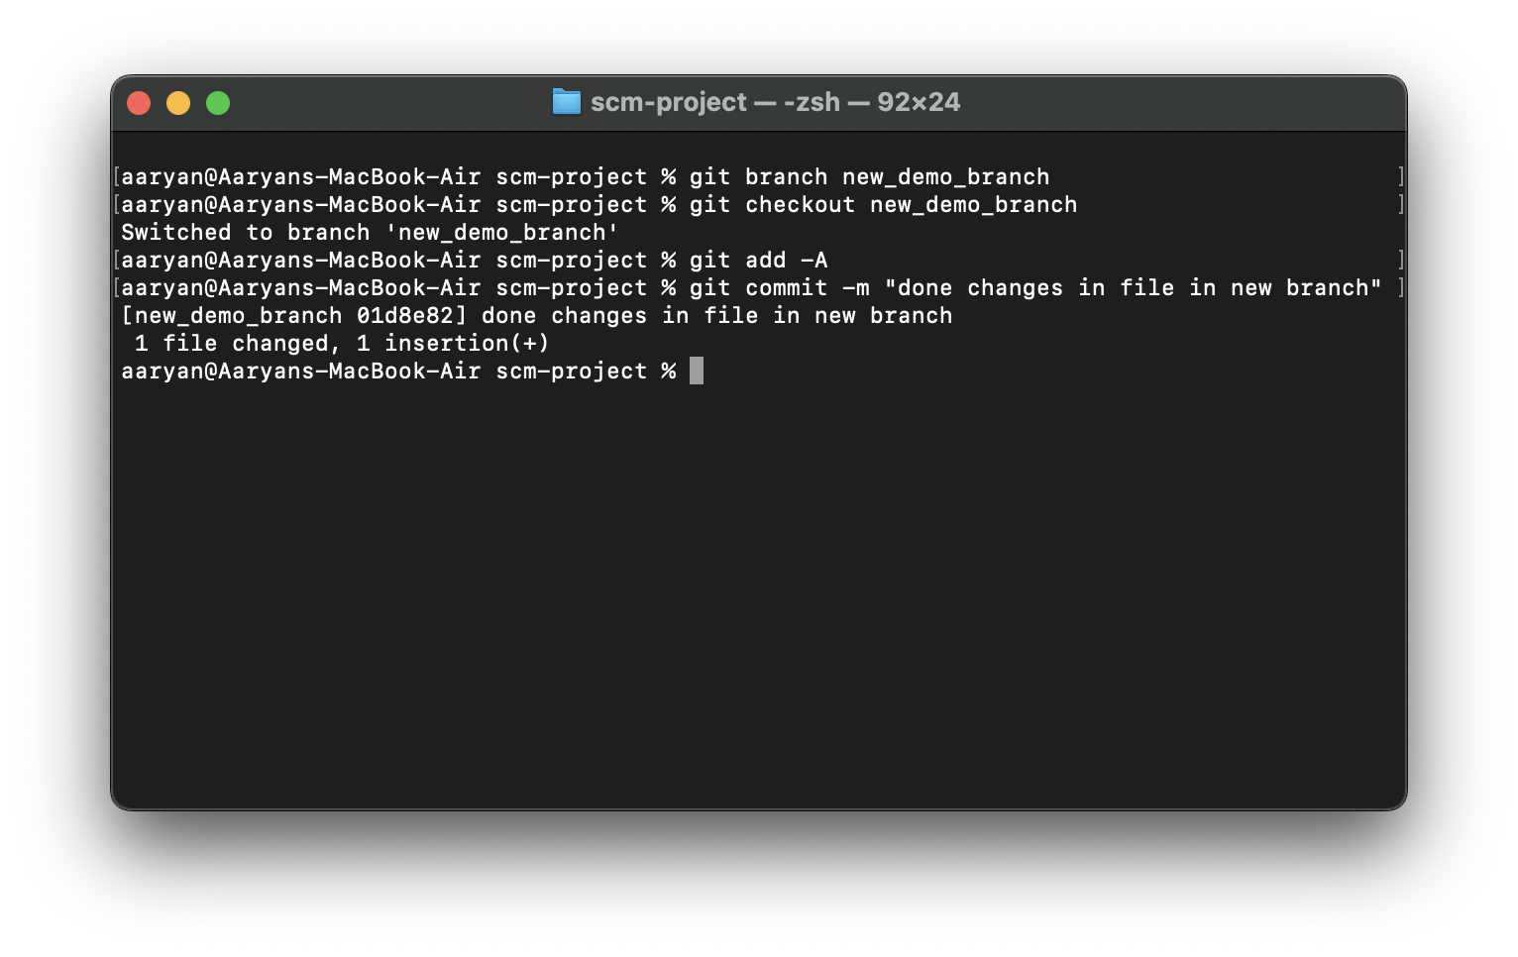3. Create a new Branch <name>. Create a new file and do changes in it and commit it.

4) Commit is made on the fork Repository



Merge and Resolve conflicts created due to own activity and collaborators activity.

1. Do changes in master branch and commit those change. And checkout to the new branch and again do changes and commit it. Now checkout to master branch and merge the branch in master.

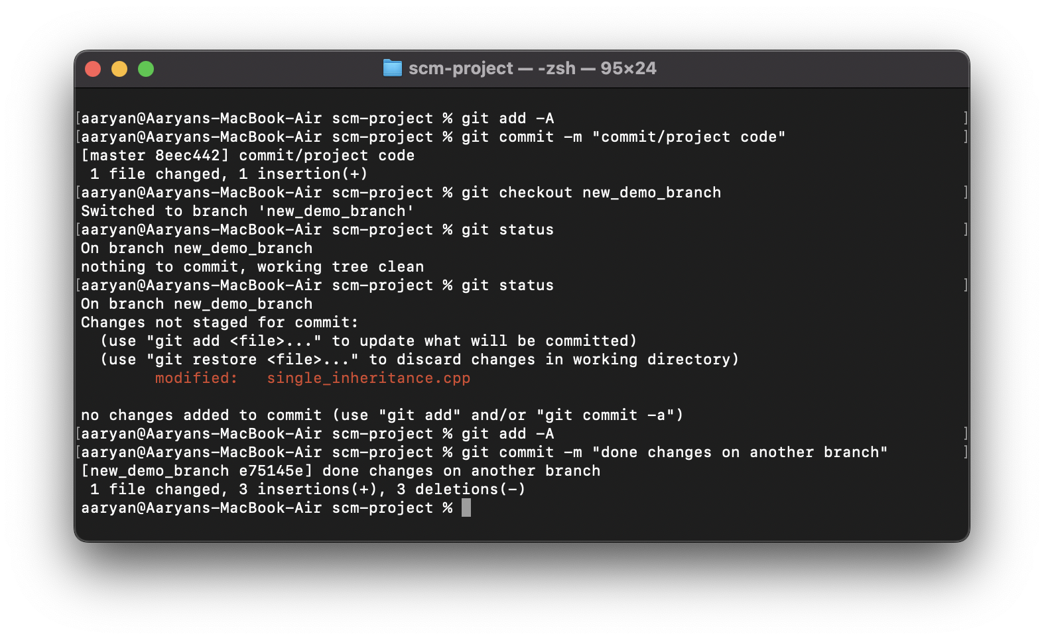

Now if any conflict arises due to the activities performed.

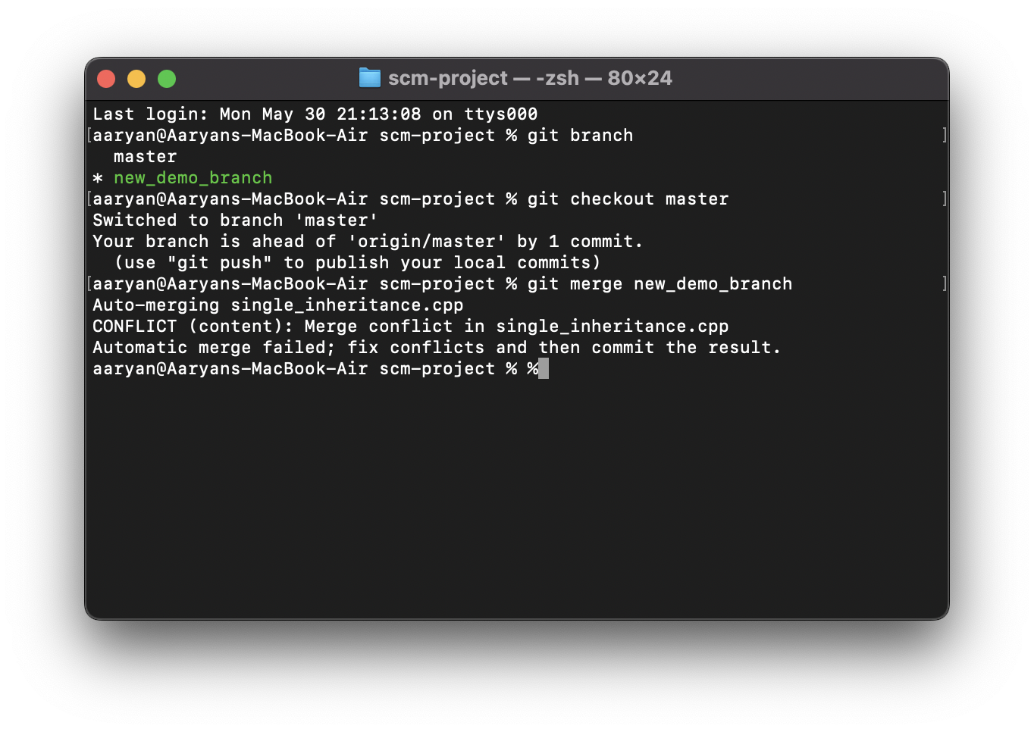

Now open the merge tool using $git mergetool and resolve the conflict then press Esc and type “:wq” and press Enter.

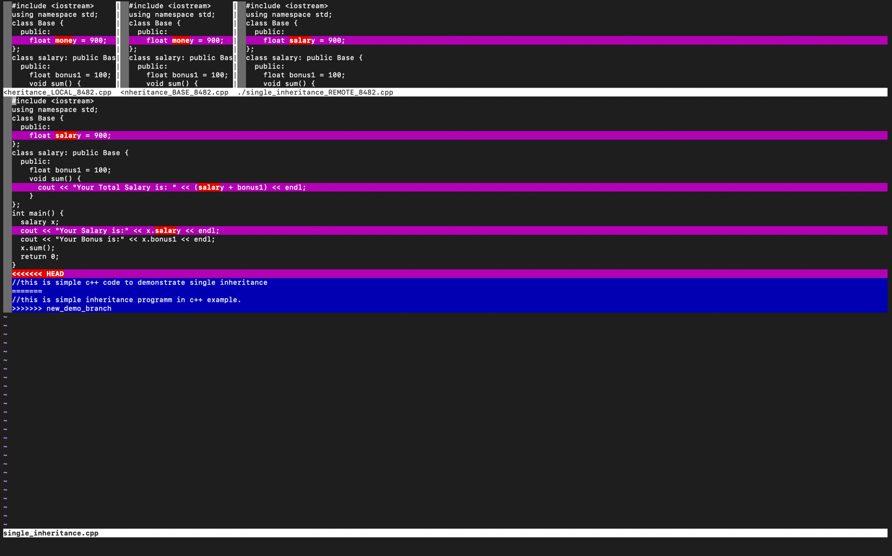



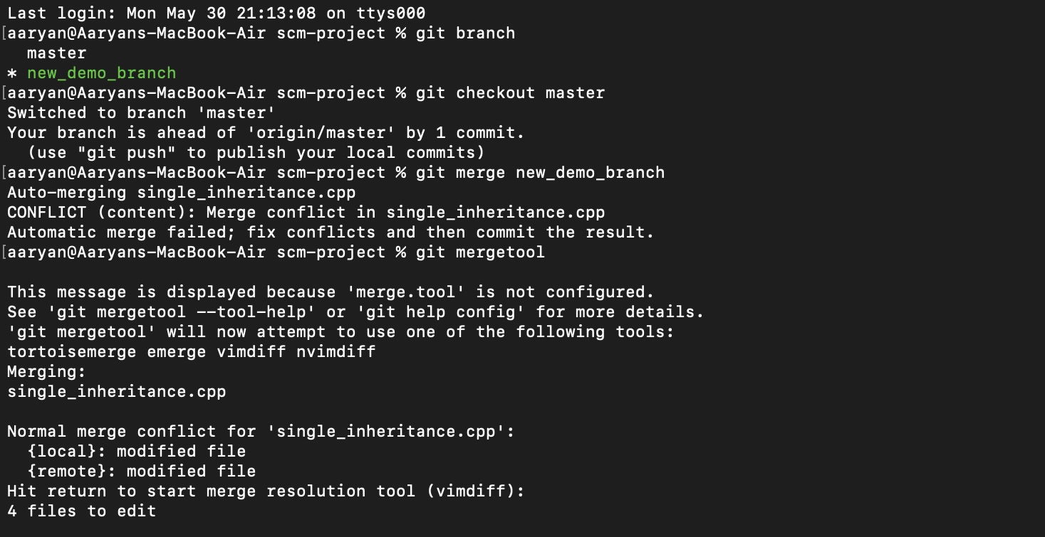

Reset and Revert

### Git Revert

The git revert command is essentially a reverse git cherry-pick. It creates a new commit that applies the exact opposite of the change introduced in the commit you’re targeting, essentially undoing or reverting it

1. 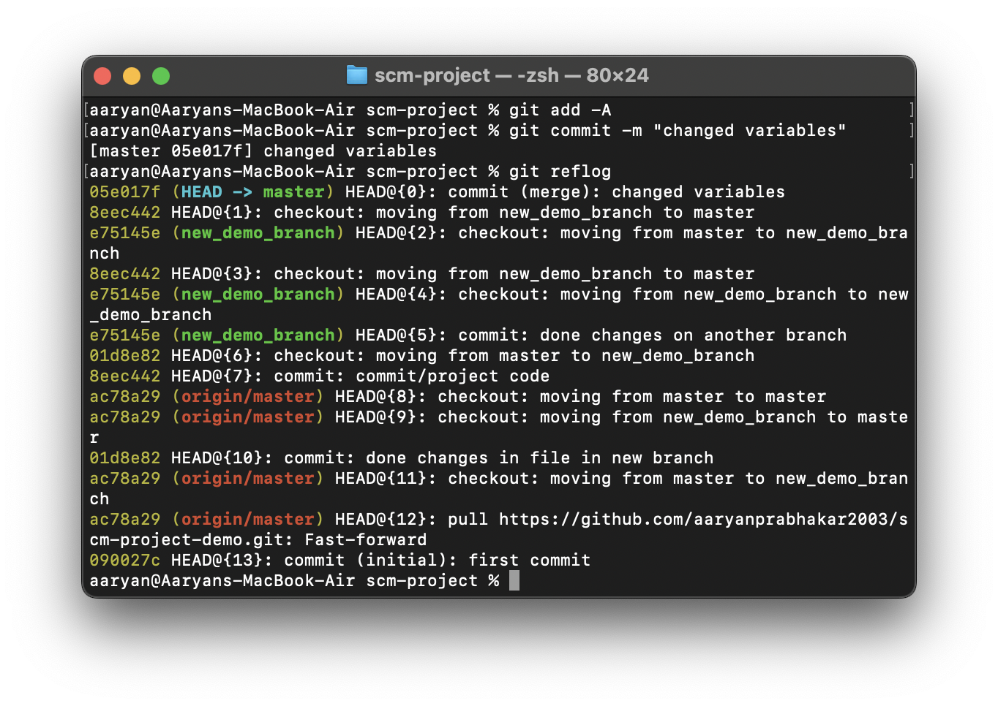Do some changes to a file and Commit them.

1. On Git Bash CLI, Type command “git Command <Commit id>”. It reverts the changes that done before Commit.

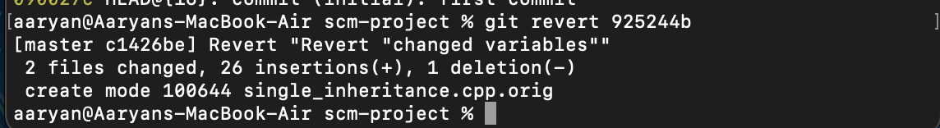

### Git Reset

RESET is the command we use when we want to move the repository back to a previous commit, discarding any changes made after that commit.

1. 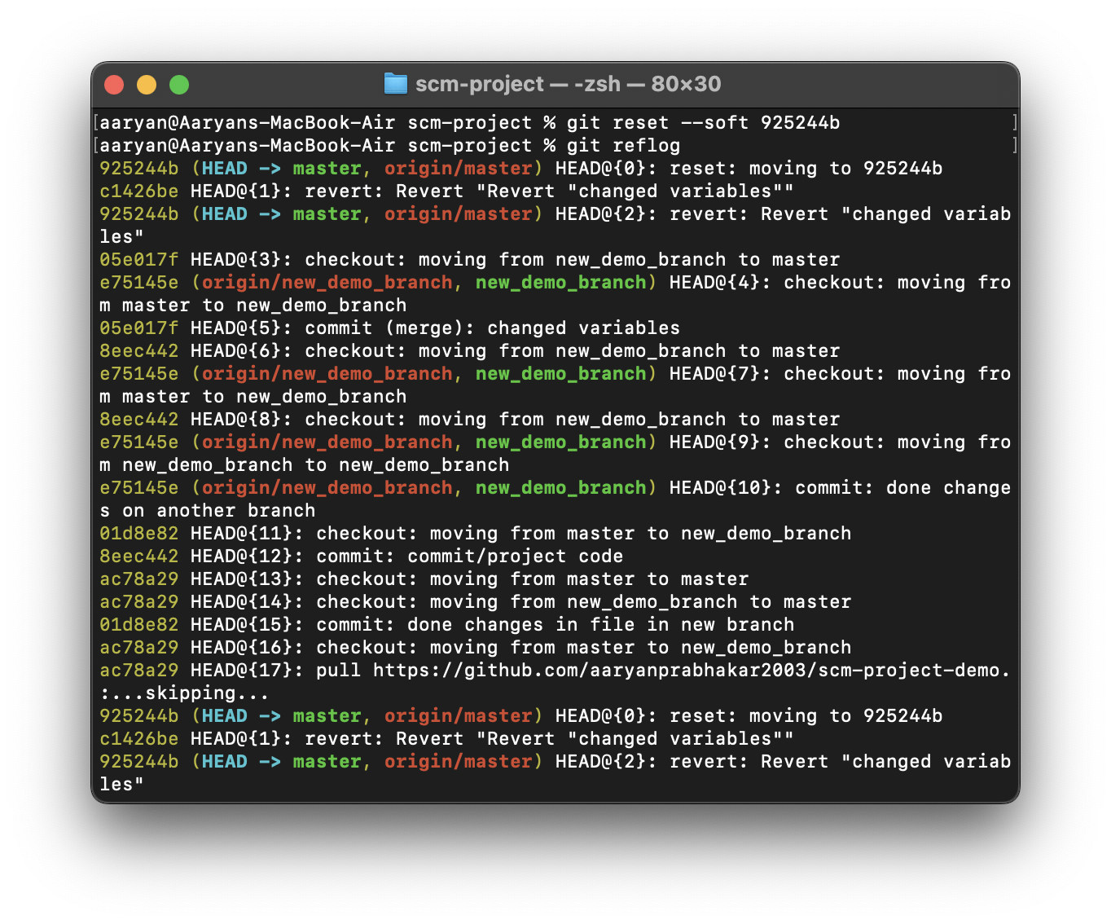Type command “git reset –soft <Commit ID>”.